AUTONOMOUS IMAGE CARTOONIFICATION USING CONVOLUTION AND TOEPLITZ MATRIX-BASED FILTERING IN ROBOT VISION

A PROJECT REPORT

Submitted by

KODURU CHANDANA— Reg. No. CH.SC.U4AIE24035
MOHAN SURENDRA — Reg. No. CH.SC.U4AIE24047
TEJASWI REDDY — Reg. No. CH.EN.U4RAI24037

in partial fulfillment for the award of the degree of

BACHELOR OF TECHNOLOGY(AIE,RAI)

Under the guidance of
Dr. K.ANITHA, Dr. SOUMYENDRA SINGH

Submitted to



DEPARTMENT OF MATHEMATICS (S&H)
AMRITA SCHOOL OF COMPUTING
AMRITA VISHWA VIDYAPEETHAM
CHENNAI – 601103

March 2026



BONAFIDE CERTIFICATE

Certified that this project report " AUTONOMOUS IMAGE CARTOONIFICATION USING CONVOLUTION AND TOEPLITZ MATRIX-BASED FILTERING IN ROBOT VISION " is the bonafide work of KODURU CHANDANA(Reg.No.CH.SC.U4AIE24035) MOHAN SURENDRA (Reg. No. CH.SC.U4AIE24047)TEJASWI REDDY (Reg. No. CH.EN.U4RAI24037).who carried out the project work under my supervision.

SIGNATURE SIGNATURE

Dr. K ANITHA Dr. SOUMYENDRA SINGH
Chairperson Assistant Professor (Sr)
Department of Science & Humanities Department of Mathematics(S&H)
Amrita School of Engineering Amrita School of Engineering
Amrita Vishwa Vidyapeetham Amrita Vishwa Vidyapeetham
Chennai Campus. Chennai Campus.



DECLARATION BY THE CANDIDATE

I declare that the report entitled " AUTONOMOUS IMAGE CARTOONIFICATION USING CONVOLUTION AND TOEPLITZ MATRIX-BASED FILTERING IN ROBOT VISION " submitted by me for the degree of Bachelor of Technology is the record of the project work carried out by me under the guidance of Dr. K.Anitha, Dr.Soumyendra Singh and this work has not formed the basis for the award of any degree, diploma, associateship, fellowship, or title in this or any other University or other similar institution of higher learning.

SIGNATURE

KODURU CHANDANA
Reg. No. CH.SC.U4AIE24035
MOHAN SURENDRA
Reg. No. CH.SC.U4AIE24047
TEJASWI REDDY
Reg. No. CH.EN.U4RAI24037

ABSTRACT

Image cartoonification is a technology that transforms images of nature into cartoon-like representations with less texture information and maintaining significant structural borders. The suggested project involves an independent robot vision system of real-time image cartoonification with mathematically structured image processing tools. The system combines the use of Yolo8 object detection to find objects in an input frame and uses a weighted scoring pattern to select the most important object in the frame with consideration to area, spatial centrality and object detection confidence. Once the area of interest has been selected a stylization pipeline is run which consists of convolution-based smoothing, edge detection and color quantization with the use of K-Means clustering algorithm. Convolution filtering is represented by Toepiltz matrix representation, and it represents the filtering in terms of a linear shift-invariant system and it makes the smoothing process mathematically clear. The stylization process will eliminate high-frequency texture elements and leave prominent structural edge to produce cartoon-like visual products. Quantitative assessment of the system, i.e., color simplification ratio and the mean squared error, proves that the system has reached the proper balance between the abstraction and the structural preservation. The suggested system is a combination of computer vision, signal processing, and machine learning systems that generate computationally efficient and aesthetically plausible cartoonized images applicable in robotic and embedded vision applications.

Keywords: Image Cartoonification; Robot Vision; Convolution Filtering; YOLOv8 Object Detection and K-Means Clustering.

ACKNOWLEDGEMENT

This project work would not have been possible without the contribution of many people. It gives me immense pleasure to express my profound gratitude to our honorable Chancellor Sri Mata Amritanandamayi Devi for her blessings and for being a constant source of inspiration throughout this work.
I am indebted to extend my gratitude to our Director, Mr. I B Manikantan, Amrita School of Engineering, for providing all facilities and extended support to gain a valuable education and learning experience.
I register my special thanks to Dr. V. Jayakumar, Principal, Amrita School of Engineering and Chairperson, Department of Mechanical Engineering, and Dr. K. Anitha, Chairperson, Department of Science and Humanities, for the support given to me in the successful conduct of this project. I wish to express my sincere gratitude to my supervisor Dr. K.Anitha, Dr.Soumyendra Singh for the inspiring guidance, personal involvement, and constant encouragement during the entire course of this work.
I am grateful to the Project Coordinator, Review Panel Members, and the entire faculty of the Department of Mathematics for their constructive criticism and valuable suggestions, which have been a rich source of improvement in the quality of this work.

KODURU CHANDANA
Reg. No. CH.SC.U4AIE24035
MOHAN SURENDRA
Reg. No. CH.SC.U4AIE24047
TEJASWI REDDY
Reg. No. CH.EN.U4RAI24037
TABLE OF CONTENTS

CHAPTER NO. | TITLE | PAGE NO.
 | Abstract | iv
 | Acknowledgement | v
 | List of Figures | vii
 | List of Symbols and Abbreviations | vii
1 | INTRODUCTION | viii
 | 1.2 image cartoonifiaction | viii
 | 1.3 objective of the study | viii
2 | LITERATURE REVIEW | viii
 | 2.1 image cartoonification techniques | viii
3 | PROBLEM STATEMENT AND METHODOLOGY | ix
 | 3.1 Problem Statement | ix
 | 3.2 Research Objectives | ix
4 | DATASET AND ANALYSIS | x
 | 4.1 image dataset and acquisition | x
 | 4.2 object detection and analysis | x
5 | SYSTEM FORMULATION AND DESIGN | xi
 | 5.1 mathematical representation of image | xi
 | 5.2 convolution and filtering | xi
 | 5.3 colour quantization using k means clusturing | xii
6 | RESULTS AND DISCUSSION | xii
 | 6.1 object detection results | xiii
 | 6.2 object selection and priortization | xiii
 | 6.3 stylization results | xiii
 | 6.4 colour simplification analysis | xiii
 | 6.5 discussion of results | xiv
7 | CONCLUSIONS AND FUTURE SCOPE | xiv
 | REFERENCES | xiv

LIST OF FIGURES

FIGURE NO. | TITLE | PAGE NO.
4.1 | Sample input image used for cartoonification. | 10
5.1 | Workflow of the proposed autonomous cartoonification system. | 11
5.2 | Effect of convolution-based smoothing on an image. | 11
6.1 | Object detection results using YOLOv8 with bounding boxes. | 12
6.2 | Cartoonification result showing original image and stylized output. | 13

LIST OF SYMBOLS AND ABBREVIATIONS

CNN | Convolution neural network
YOLO | You Only Look Once
RGB | Red Green Blue
MSE | Mean Squared Error
CSR | Color Simplification Ratio
ROI | Region of Intrest

INTRODUCTION
Image processing has a history spanning thousands of years, starting with the earliest written documents that emulated textbooks by instructing the transfer of ideas between their brains and parchment or paper (Palacio 2005).Digital image processing is a significant branch of computer science area that deals with the analysis and transformation of visual data with the help of computational means. A digital image can be mathematically expressed as a two-dimensional discrete function where every element is expressed correspondingly as a pixel intensity value. The color images have three separate matrices with the perception of the Red, Green, and Blue (RGB) channels, whereas in grayscale images, the pixel values reflect the brightness. With this operation, the images can be manipulated with principles of linear algebra, signal processing and optimization.

1.2 Image Cartoonification
Image cartoonification is a form of stylization which transforms real-life images into cartoonish forms. Surprisingly, cartoon pictorials in contrast to realistic photos usually have plane areas of color, less textural information, and tough outlines that show the borders of objects. The primary goal of cartoonification is to reduce the visual complexity without necessarily eliminating such significant structural elements of the image.

1.3 Objectives of the Study
The objectives of the research are specific and the following:
a) To process and capture computer vision by using a digital image.
b) To extract objects in a picture by means of the YOLOv8 deep learning model.
c) To label some essential objects with some weighted scoring scheme, according to area, centrality, and observed confidence.
d) To do the convolution-based smoothing to eliminate textures of the high-frequency.
e) To undertake an edge detection in order to maintain significant structural boundaries.
f) To use the K-Means clustering of colors and stylization.

LITERATURE REVIEW
The method of cartoonification that is applied in pictures is quite dependent on human beings interpretation since most forms of art that have been developed in the past were not guided by mathematical guidelines. As computer vision and the processing of digital images have evolved, scholars have been trying to come up with computational designs which can automatically transform real world images into cartoon like images, yet capture significant visual features.

2.1 Image Cartoonification Techniques.
Computer vision Computer Non-photorealistic rendering Image cartoonification has been a popular research in both computer vision and non-photorealistic rendering. The initial methods primarily used mathematical methods of filters that helped to reduce textures in images and retain relevant structural edges. Bilateral filtering which became known as edge-preserving filters were developed to smooth images without distorting object boundaries [3]. On the same note, approaches founded on anisotropic filtering and video abstraction processes have been suggested to generate stylized results without losing valuable structural information [21], [23].

Color quantization is also another significant method employed in cartoonification. The process decreases the amount of different colors used in an image and results in flat color areas that look like cartoon drawings. This is frequently applied to clusters of similar pixels using clustering algorithms like K-Means which cluster similar pixel values together and reconstruct them with centroid colors which represent them [5], [26]. The images are stripped of the complexity of colors, therefore they have a visual simplicity and style.With the invention of the deep learning method, the object detection has improved dramatically. Convolutional Neural Networks (CNNs) have extensively been applied in the digital image recognition and classification of objects [6], [7]. The YOLO (You Only Look Once) model is considered one of the most popular object detection algorithms because it is very fast and has accuracy in real-time object detection activities among many other proposed object detection algorithms [2].

3.1 Problem Statement
As computer vision and image processing technologies rapidly evolve, there has been an increased requirement to have systems that can automatically solve visual data and convert it effectively. The cartoonification of images is one of these transformation methods that transform natural images into simplified cartoon-like images through minimizing the details of textures and highlighting strong edges. The approach that has been traditionally used to cartoonify the image involves stylization of the whole picture without paying attention to which objects will be the most significant one in the pictureMaking the entire image uniformly processed might add more complexity to calculation, and the results might have superfluous background information. In most real world scenarios, particularly robotic vision systems are more practical by first finding and ranking important objects in the image prior to implementing image transformations.

3.2 Research Objectives
This project seeks to design and deploy an autonomous cartoonification system which combines methods of object and image detection and mathematical image processing.
The targeted objectives of the study include:
a) To extract and process computer vision digitized images.
b) To recognize objects that are in the picture with the YOLOv8 deep learning model of object detection.
c) To choose the most interesting object in the image with a weighted scoring system as far as geometric area, spatial centrality and detection confidence.
d) Use convolution-based smoothing in order to replace the textures and noise causes by high-frequency in the selected image region.
e) To carry out edge detection in order to maintain high structural boundaries of objects.
f) To use K-Means clustering to quantize colors to elicit fewer number of distinct colors and form flat cartoonish colored areas.
g) To create cartoon images which are aesthetically simplified but keep significant structure information.

DATASET AND ANALYSIS
The dataset comprises images obtained through the use of the digital camera.

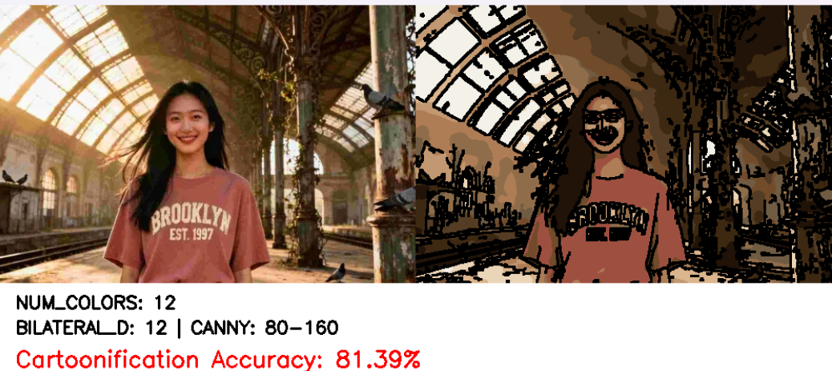
Figure 4.1: Sample input image used for cartoonification.

4.1 Image Dataset and Acquisition

The dataset includes the pictures that were taken using the digital camera.
The data in this project is in the form of digital images taken through the use of the web camera and associated sample images in which computer vision algorithms are tested that are available in the internet. All pictures exist in the form of RGB, whereby the color data of the picture exist in red, green and blue channels. The proposed cartoonification system uses these pictures as its input.The images are then resized and scaled to normal in order to guarantee uniformity when detecting objects and stylizing them before processing. There can be various objects, backgrounds and different lighting effects in the input images. With the variety of images, it can be used to test the stability of the developed system to work with various scenes and visual challenges.

4.2 Object Detection Analysis

The second step of the analysis is to recognize objects in the input images with help of YOLOv8 deep learning model. YOLOv8 can detect various objects simultaneously on an image and it can provide information about the objects bounding boxes coordinates, predicted class name and confidence scores. These outputs are useful in determining the position and type of objects in the image.In case several objects are identified, the system uses a weighted scoring system to identify the object to be chosen in the further process. The scoring system judges the objects in terms of size, their location in the frame as well as their detection confidence. Larger or those objects in the middle fore part of the image are usually given more scores.

Once the target object has been chosen, the stylization pipeline is used to turn the chosen region into a cartoon appearance. Smoothing in high frequency detail of textures and noise at the expense of valuable structural features is implemented using contraction of the image which is subsequently followed by convolving the result with a filter.Powerful object borders are then properly de-jittered with the help of edge detection algorithms.

SYSTEM FORMULATION AND DESIGN

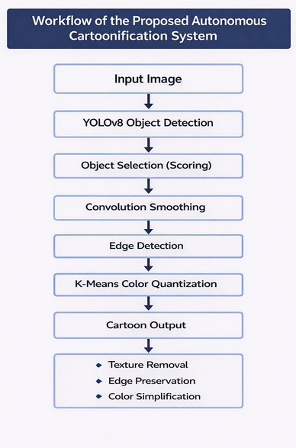
Figure 5.1: Workflow of the proposed autonomous cartoonification system.

5.1 Mathematical Representation of Images
During digital image processing, an image may be mathematically represented as a 2-dimensional array with every value associated with the intensity of a pixel. In the case of a grayscale image having the size of mxn, the image may be represented as the matrix I(i,j), i and j being the spatial location of the pixel. Three independent matrices denoted by Red, Green and Blue (RGB) signify the color channels in the case of color images. Different image processing functions like filtering, transformation, and clustering can be done using the method of linear algebra with the help of this mathematical representation. In the proposed system, the image taken will first be represented using a matrix of numbers in ensured way that the image information can be mathematically operated. This representation acts as the basis on which further image processing action like convolution, edge detection and color quantization is done.

5.2 Convolution and Filtering
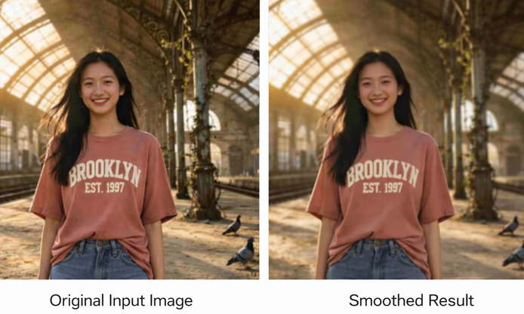
Figure 5.2: Effect of convolution-based smoothing on an image.
One of the most essential operations in the image processing is convolution. It is usually employed to carry out smoothing, noise reduction and feature extraction. In convolution, an image is manipulated with the help of a small matrix known as a kernel or filter and pixel values are revised according to the weighted mean of adjacent pixel values. Convolution may be represented mathematically as follows:
$$Y(i,j)=\sum_{m}{\sum_{n}{I(i-m,j-n)K(m,n)}}$$
In which, I denotes the input image, K denotes the convolution kernel and Y denotes the filtered output image. In this project, smoothing is employed to reduce the high-frequency-based texture and noises in the image without destroying significant structural details in the image using the convolution technique. The stylization process is made ready through the filtering process of the image, which reduces the fine details, but preserves the overall outlay.

5.3 Color Quantization using K-Means Clustering
Another process that is significant in cartoonification is color quantization because the number of different colors of the cartoon picture is usually fewer than the number of different colors of the natural picture. Within the framework of the offered system, the K-Means clustering is applied to decrease the amount of colors in the image. The K-Means clustering algorithm is used to cluster together similar pixel colors in a cluster using their distance to cluster centroids. The algorithm aims at reducing the intra-cluster variance and this can be mathematically stated as:
$$min⁡\sum_{i=1}^{k}{\sum_{x∈C_{i}}{∥x-}}μ_{i}∥^{2}$$
with C i denoting the pixel set of cluster i, and 0 i denoting the centroid of the cluster. The image is changed into simplified color regions by substituting the colors that make a pixel with the centroid of the cluster that a pixel is associated with. This simplification of colors creates two-dimensional and uniform spaces who look like cartoon figures. This integration of mathematic image representation, filtering in form of convolution and clustering in form of color quantization makes up the fundamental premise of the proposed autonomous cartoonification system.

RESULTS AND DISCUSSION
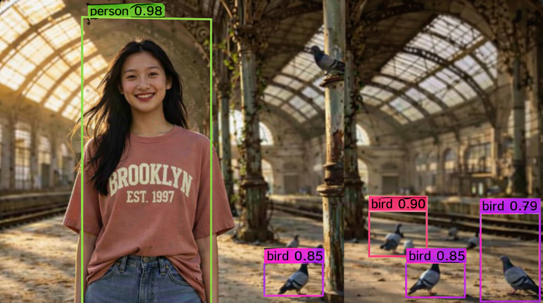
Figure 6.1: Object detection results using YOLOv8 with bounding boxes.
6.1 Object Detection Results
The initial phase of the suggested system is to identify objects in the input image with the help of the YOLOv8 deep learning model. When applied to the scene, the model is able to identify several objects in the image and the model gives bounding box coordination, class labels, and the confidence score of each object detected. These results of detection prove that YOLOv8 can effectively identify objects in various light conditions and under a variety of backgrounds. Bounding boxes are used to visually indicate the detected objects to provide an understanding of the regions of interest on which additional processing will be done.The process of selecting and prioritizing objects must occur as an initial step in the perception process to reduce the number of objects assigned to the initial processing stage.

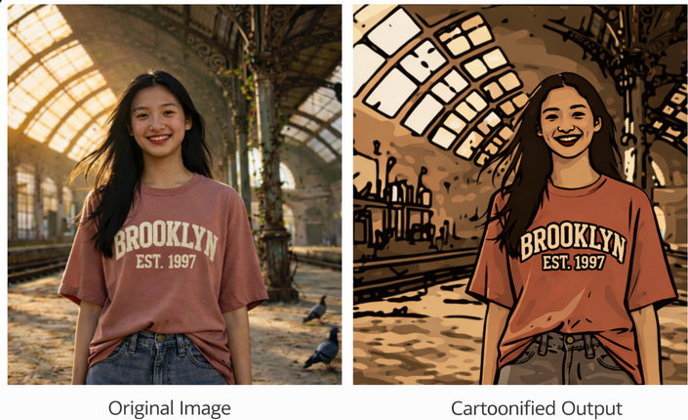
Figure 6.2: Cartoonification result showing original image and stylized output.
6.2 Object Selection and Prioritization
In case several things are identified in the input image, the system uses the weighted scoring system to ascertain the most germane one that will be stylized. Some of the parameters which the scoring function takes into account include the area of an object, centrality of the object in the image and the detection centrality. Bigger objects, closer to the center of the image, and recognized as more certain get high scores. This prioritization mechanism will guarantee that the object of greatest importance in the picture is chosen to be cartoonified to enhance the visual resolution, as well as, computational efficiency.

6.3 Stylization Results
Once the target object is chosen, stylization pipeline is used to transform the chosen part to a cartoon image like object. Smoothing of the image is then done by using convolving in order to eliminate fine textures and noise in the picture, as well as safeguard significant structural details. Strong boundaries of the objects are then extracted using edge detection algorithms. These lines form the thick lines that cartoon artworks are known to have. The stylization results indicate that the system is effective to generate simplified images having distinct object definitions.

6.4 Color Simplification Analysis.
Color quantization is also done through K-Means clustering which minimizes the number of colors in the image. This algorithm clusters together similar pixel colors by grouping them together and the groups are represented by centroid values. It is how flat and uniform areas of color are formed resembling cartoon-like figures. As it has been observed experimentally, the decrease in color complexity ensures a substantial improvement of visual appearance of the stylized output without altering significant structural details.

6.5 Discussion of Results
As the experimental data shows, the given system is effective in integrating both the object detection and mathematical image processing approaches in order to create cartoon-style images. Based on the adaptability of YOLOv8 on object detection, combined with convolution-smoothing, edge draughting, and color quantization, offers a sequence of computations in which the autonomous stylization may be organized systematically. The system is effective in simplifying textures, structural boundaries and color complexities and is computationally efficient. At large, the findings suggest that the specified solution can produce visually meaningful cartoon images, which can be used in computer vision software in real-time.

7.1 Conclusions
This project introduced an independent system of cartoonification of images where computer vision is used together with mathematical image processing. The proposed framework combines both the object detection of a YOLOv8 deep learning model and the stylization of the object with the use of convolution-based smoothing, edge detection, and K-Means color quantization. The system initially identifies objects in the input image and then ranks the topmost object in the resultant output utilizing a weighted scoring system contingent on region, spatial centrality and confidence of detection.The results of the experiment indicate that the suggested way can create cartoon results with a high degree of efficiency. Making the system interpretable, efficient, and applicable in real-time, the combination of mathematical modeling and artificial intelligence makes the system efficient and suitable. On the whole, as demonstrated in the project, the combination of the object detecting method with the image stylization method allows achieving the results of the so-called cartoonification that are effective and not only attractive to the eye.

7.2 Future Scope
Though the given system works quite well, some areas of improvement can be considered in the future practice to increase the level of performance and functionality of the cartoonification system.
a) The system can be scaled to accept real-time video streams rather than still images and live cartoonify video applications.
b) More developed deep learning architecture can be used to stylize artworks to achieve more heavy cartoon effects.
c) Edge preservation and texture smoothing can be enhanced by means of adaptive filtering techniques in different conditions of lighting.
d) Acceleration Acceleration can be done using GPU to provide an additional boost to computational capability and allow real time processing to occur quickly.
e) Multiple objects stylization can be pursued in a way that several objects that have been identified in a scene are stylized.
Such refinements would also improve the visual quality, scaling, and real-time of the suggested cartoonification system.

REFERENCES

[1] R. C. Gonzalez and R. E. Woods, Digital Image Processing, 4th ed., Pearson, 2018.
[2] J. Redmon, S. Divvala, R. Girshick, and A. Farhadi, “You Only Look Once: Unified, Real-Time Object Detection,” in Proceedings of the IEEE Conference on Computer Vision and Pattern Recognition (CVPR), 2016.
[3] C. Tomasi and R. Manduchi, “Bilateral Filtering for Gray and Color Images,” in Proceedings of the IEEE International Conference on Computer Vision (ICCV), 1998.
[4] L. A. Gatys, A. S. Ecker, and M. Bethge, “Image Style Transfer Using Convolutional Neural Networks,” in Proceedings of the IEEE Conference on Computer Vision and Pattern Recognition (CVPR), 2016.
[5] D. Arthur and S. Vassilvitskii, “K-Means++: The Advantages of Careful Seeding,” in Proceedings of the ACM-SIAM Symposium on Discrete Algorithms, 2007.
[6] A. Krizhevsky, I. Sutskever, and G. Hinton, “ImageNet Classification with Deep Convolutional Neural Networks,” in Advances in Neural Information Processing Systems (NIPS), 2012.
[7] K. He, X. Zhang, S. Ren, and J. Sun, “Deep Residual Learning for Image Recognition,” in Proceedings of the IEEE Conference on Computer Vision and Pattern Recognition (CVPR), 2016.
[8] D. Lowe, “Distinctive Image Features from Scale-Invariant Keypoints,” International Journal of Computer Vision, vol. 60, no. 2, pp. 91–110, 2004.
[9] H. Bay, T. Tuytelaars, and L. Van Gool, “SURF: Speeded Up Robust Features,” in Proceedings of the European Conference on Computer Vision (ECCV), 2006.
[10] P. Felzenszwalb, R. Girshick, D. McAllester, and D. Ramanan, “Object Detection with Discriminatively Trained Part-Based Models,” IEEE Transactions on Pattern Analysis and Machine Intelligence, vol. 32, no. 9, pp. 1627–1645, 2010.
[11] I. Tolstikhin et al., “MLP-Mixer: An All-MLP Architecture for Vision,” in Advances in Neural Information Processing Systems (NeurIPS), 2021.
[12] S. Mallat, A Wavelet Tour of Signal Processing. Elsevier, 1999.
[13] R. Szeliski, Computer Vision: Algorithms and Applications. Springer, 2022.
[14] I. Goodfellow, Y. Bengio, and A. Courville, Deep Learning. MIT Press, 2016.
[15] K. Simonyan and A. Zisserman, “Very Deep Convolutional Networks for Large-Scale Image Recognition,” in Proceedings of the International Conference on Learning Representations (ICLR), 2015.
[16] R. Achanta et al., “SLIC Superpixels Compared to State-of-the-Art Superpixel Methods,” IEEE Transactions on Pattern Analysis and Machine Intelligence, vol. 34, no. 11, pp. 2274–2282, 2012.
[17] P. Ott and M. Everingham, “Shared Parts for Deformable Part-Based Models,” in Proceedings of the IEEE Conference on Computer Vision and Pattern Recognition (CVPR), 2011.
[18] T. Lin et al., “Microsoft COCO: Common Objects in Context,” in Proceedings of the European Conference on Computer Vision (ECCV), 2014.
[19] A. Bochkovskiy, C. Wang, and H. Liao, “YOLOv4: Optimal Speed and Accuracy of Object Detection,” arXiv preprint arXiv:2004.10934, 2020.
[20] G. Bradski, “The OpenCV Library,” Dr. Dobb’s Journal of Software Tools, 2000.
[21] H. Winnemöller, S. Olsen, and B. Gooch, “Real-Time Video Abstraction,” ACM Transactions on Graphics, vol. 25, no. 3, pp. 1221–1226, 2006.
[22] Q. Wang and R. Hu, “Cartoon Rendering of Images and Video: A Survey,” Journal of Visual Communication and Image Representation, vol. 22, no. 1, pp. 1–15, 2011.
[23] L. Kyprianidis, J. Kang, and H. Döllner, “Image and Video Abstraction by Anisotropic Kuwahara Filtering,” Computer Graphics Forum, vol. 28, no. 7, pp. 1955–1963, 2009.
[24] E. Gastal and M. Oliveira, “Domain Transform for Edge-Aware Image and Video Processing,” ACM Transactions on Graphics, vol. 30, no. 4, 2011.
[25] Z. Farbman, R. Fattal, D. Lischinski, and R. Szeliski, “Edge-Preserving Decompositions for Multi-Scale Tone and Detail Manipulation,” ACM Transactions on Graphics, vol. 27, no. 3, 2008.
[26] M. Celebi, “Improving the Performance of K-Means for Color Quantization,” Pattern Recognition Letters, vol. 32, no. 12, pp. 1609–1617, 2011.
[27] X. Wan, G. Karypis, and V. Kumar, “Color Quantization Using Clustering Techniques,” IEEE Transactions on Image Processing, vol. 19, no. 9, pp. 2329–2341, 2010.
[28] J. Johnson, A. Alahi, and L. Fei-Fei, “Perceptual Losses for Real-Time Style Transfer and Super-Resolution,” in Proceedings of the European Conference on Computer Vision (ECCV), 2016.
[29] D. Ulyanov, V. Lebedev, A. Vedaldi, and V. Lempitsky, “Texture Networks: Feed-Forward Synthesis of Textures and Stylized Images,” in Proceedings of the International Conference on Machine Learning (ICML), 2016.
[30] S. Thrun, “Robotic Mapping: A Survey,” Exploring Artificial Intelligence in the New Millennium, 2003.
[31] Aarthi D et al., “Adaptive Gaussian Filter Based Denoising,” Mathematical Modelling of Engineering Problems, 2024.
[32] K. Anitha et al., “Random Forest Regression for Battery Health,” SSRG International Journal of Electrical Engineering, 2025.
[33] A. A. V and K. Anitha, “GRU-Based Driver Behaviour Classification,” ICNGCS, 2025.
[34] G. Mahesh and K. Anitha, “Hybrid CNN-BiLSTM for Cardiovascular Diagnosis,” ICNGCS, 2025.
[35] Karthikeyan et al., “Malaria Image Detection,” IEEE PuneCon, 2024.
[36] S. Singh and S. Sarkar, “Stochastic FitzHugh–Nagumo Using PINNs,” International Journal of Applied Computational Mathematics, 2025.
[37] S. Singh, “ELU Neural Network for Integral Equations,” Journal of Integral Equations, 2023.

